### **Step 1. Create Table**

Create a table in your SQL database as follows

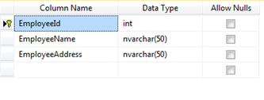

**Note:** EmployeeId is identity column.

### **Step 2. Create SSIS Project**

Click File >> New >> Project. Select Integration Services from the group. Specify some nice name. Say Ok.

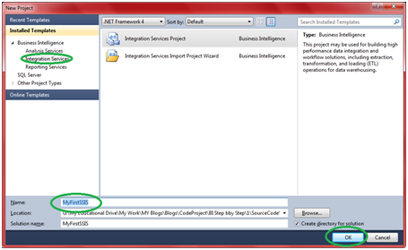

It will open up SSIS designer which you will use for creating and maintaining Integration service packages.

### **Step 3. Add Backup Database Task**

Take “Backup database task” from toolbox and add it to control flow designer window

### **Step 4. Configure Backup Database Task**

​4.1 Double click the task, it will pop up the configure window.

### **https://www.codeproject.com/KB/database/771871/configure-window.png**

4.2 The first thing to configure in connection in the top. Select the connection manager to one created in step 3.

**Note:**A very strange thing will happen here. You will not find the connection manager (created in step 3) in the drop down. For that,

4.2.1 Close the window.

4.2.2 Right click your connection manager and go to properties.

4.2.3 Check the value of Qualifier property. It will be something like this, “System.Data.SqlClient.SqlConnection, System.Data, Version=4.0.0.0, Culture=neutral, PublicKeyToken=b77a5c561934e089”.

4.2.4 Change it to Simple “SQL”.

4.2.5 Double click the Backup task again. Now you will find the connection manager in dropdown box.

4.3 Just below connection you will find Database(s) option. Select one or more database from the list.

4.4 Let other setting as it is, only select the path where you want to keep database backups.  
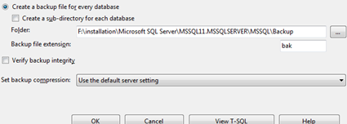

4.5 Click Ok

### **Step 5. Execute the Package**

Press F5 and execute the package.  
